**Lab Instructions and Solution for Module- 4: Course Assign and Showing this Course of our Grading System Project**

**Objectives**

After completing this module you will be able to:

* After login, Admin assign courses for the teacher
* After login, Teacher see assign courses
* Teacher see create tutorial option, tutorial marks entry option of student’s

**Task 1: Design of Assign Course and Creating a table based on our project**

|  |  |
| --- | --- |
|  |  |

1. After Admin login he/she see the following option(Fig-1).you design the following UI(Fig-1).This form name is **admin_form.cs** which create in Admin folder(Fig-2).

**1**

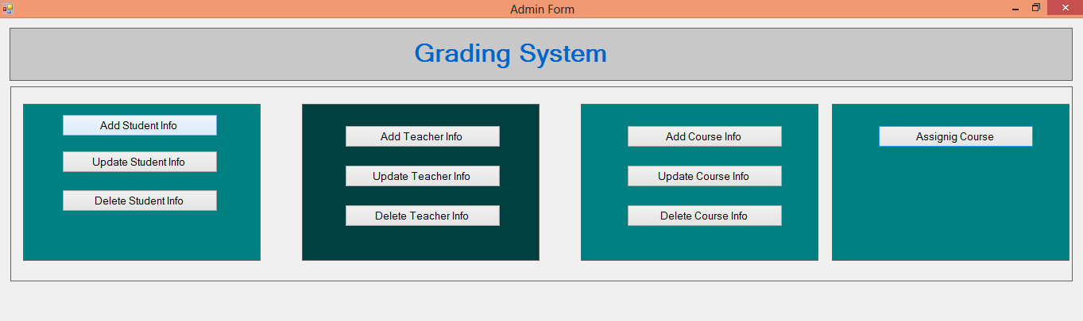

**2**

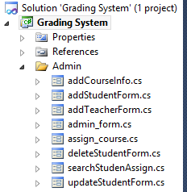

1. Now we click Assining Course Button(Fig-1) and see the following design which you will make(Fig-3).This form name is **assign_course.cs** which create in Admin folder (Fig-2). Here we drag two dataGridView in assign_course form.

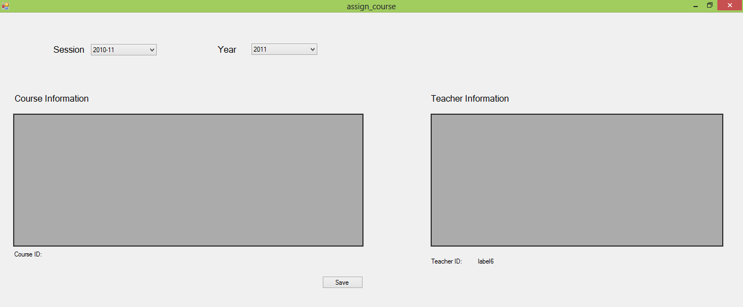

courseidL

teacheridLB

**3**

1. Now select all Course Information and Teacher Information from **course_info** and **teacher_info** table which create in **gradingsystem_db** database in previous module.

For this work,Create a class file name is **information_load.cs** which create in Database folder(Fig-4) and write the following code for dataGridview,Get Teacher Id & Course Id

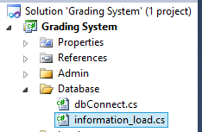

**4**

class information_load

{

MySqlConnection con = Database.dbConnect.Initialize();

int returnid;

string returnvalue;

public void datagridview_load(String query, DataGridView dgv)

{

try

{

con.Open();

MySqlCommand cmd = new MySqlCommand(query, con);

DataTable dataTable = new DataTable();

using (MySqlDataAdapter da = new MySqlDataAdapter(cmd))

{

da.Fill(dataTable);

}

dgv.MultiSelect = false;

dgv.SelectionMode = DataGridViewSelectionMode.FullRowSelect;

dgv.DataSource = dataTable;

dgv.DataMember = dataTable.TableName;

dgv.Refresh();

}

catch (Exception ex)

{

MessageBox.Show(string.Format("An error occured {0}", ex.Message), "Error", MessageBoxButtons.OK, MessageBoxIcon.Error);

}

finally

{

if (con != null)

con.Close();

}

}

public int get_id(string query)

{

try

{

con.Open();

MySqlCommand cmd = new MySqlCommand(query, con);

MySqlDataReader reader = cmd.ExecuteReader();

if (reader.Read())

{

returnid = Convert.ToInt32(reader.GetString(0));

}

reader.Close();

con.Close();

return returnid;

}

catch (Exception ew)

{

MessageBox.Show("Error occured .Message - " + ew.Message, "Error", MessageBoxButtons.OK, MessageBoxIcon.Error);

con.Close();

return returnid;

}

}

}

1. Now we doble click on assign_form and write the following code

Database.dbConnect dbo = new Database.dbConnect();

Database.information_load il = new Database.information_load();

private void assign_course_Load(object sender, EventArgs e)

{

sessionCB.SelectedIndex = 0;

yearCB.SelectedIndex = 0;

il.datagridview_load("SELECT `c_id`, `c_title`, `c_code`, `credit`, `session`, `semester` FROM `course_info`", courseDGV);

il.datagridview_load("SELECT `t_id`, `t_name`, `t_s_code`, `t_desig`, `t_dept` FROM `teacher_info`", teacherDGV);

}

1. After doing this we will see the following picture(Fig-5)

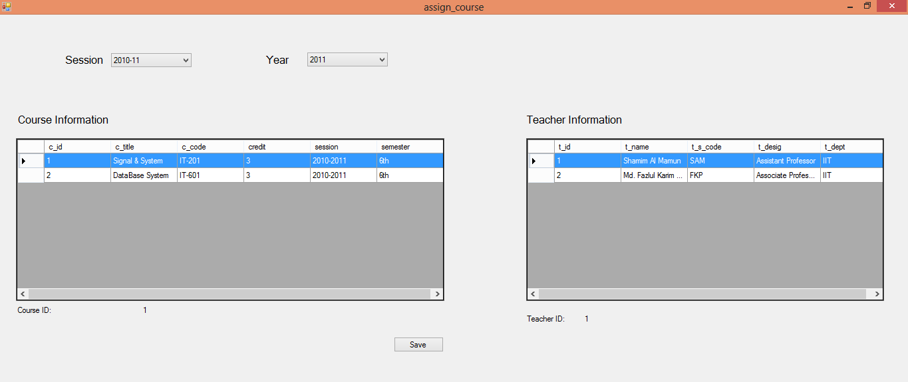

teacherDGV

V

courseDGV

**5**

1. Now we will go to the Phpmyadmin and create table as name “**course_assign_info**” and Field name like this(Fig-6).

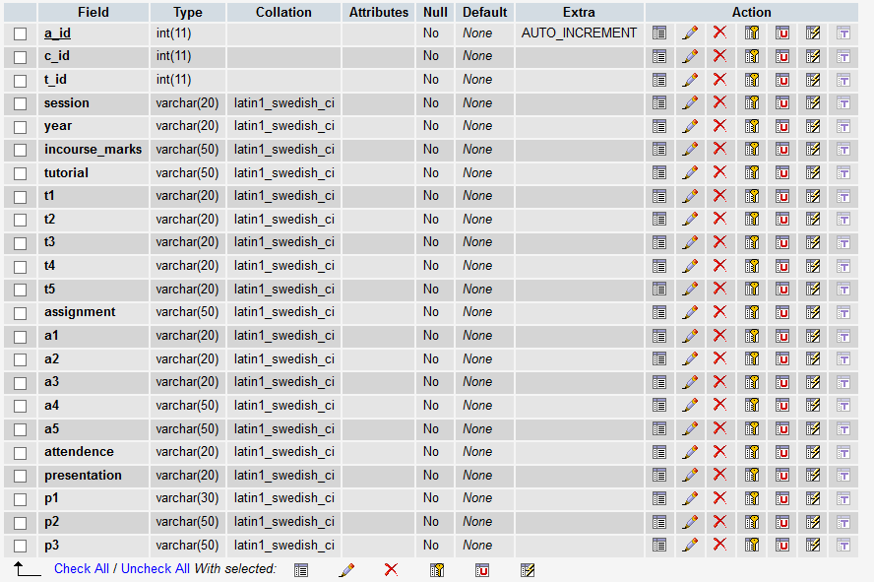

**6**

1. Now we select dataGridView cell for select Course Information and Teacher Information.For this reason we will go to dataGridView properties and select Events.

For Course Information(Fig-) and Teacher Information(Fig-). Double click on the Cell Click and write the following code .

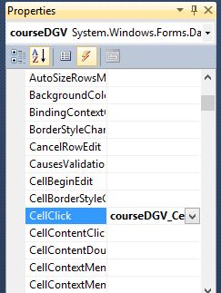

Events

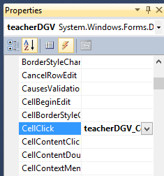

private void courseDGV_CellClick(object sender, DataGridViewCellEventArgs e)

{

courseidL.Text = courseDGV[0, e.RowIndex].Value.ToString();

}

private void teacherDGV_CellClick(object sender, DataGridViewCellEventArgs e)

{

teacheridLB.Text = teacherDGV[0, e.RowIndex].Value.ToString();

}

1. Now we work with Save Button(Fig-5).After select Course and Teacher Information We save this information in the database which table name is “**course_assign_info**”

private void saveB_Click(object sender, EventArgs e)

{

if (courseidL.Text == "" || teacheridLB.Text == "") {

MessageBox.Show("Please select at least one course and one teacher");

return;

}

string query = "INSERT INTO `gradingsystem_db`.`course_assign_info` (`a_id`, `c_id`, `t_id`, `session`, `year`) VALUES (NULL, '"+courseidL.Text+"', '"+teacheridLB.Text+"', '"+sessionCB.SelectedItem+"', '"+yearCB.SelectedItem+"');";

dbo.Insert(query);

int aid = il.get_id("SELECT max( a_id ) FROM `course_assign_info` ");

string create_query = "CREATE TABLE IF NOT EXISTS `gradingsystem_db`.`" + aid + "` (`s_e_roll` INT NOT NULL)";

dbo.Insert(create_query);

}